LITERATURE REVIEW – CARBON SEQUESTRATION IN MANGROVES
Sustainable conservation and management of natural ecosystems is now viewed as extremely important to mitigate the impacts of climate change (Sivakumar and Stefanski, 2011). A rapid increase in greenhouse gas emissions is already making coastal systems more vulnerable to sea-level rise and storm surges (Stocker et al., 2013; Pearson et al., 2014; Ahmed and Glaser, 2016). Meanwhile, the awareness on carbon emissions and strategies like REDD+ (Reducing Emissions from Deforestation and forest Degradation) that insist on economic growth while maintaining carbon neutrality are drawing a global attention (Aziz et al., 2016; Robiou Du Pont et al., 2017).

Mangrove ecosystems play an important role for carbon sequestration (Twilley et al.,1992, Bouillon et al., 2008) and is one of the most relevant blue carbon sources (Macreadie et al., 2019). Donato et al. (2011) reported that mangrove forests have an average carbon stock of 1,023 Mg C ha⁻¹ in the Indo-Pacific region, making it one of the most important ecosystems acting as a carbon sink.
With a total global extent of 137600 Km² (Bunting et al., 2018), mangroves are estimated to stock a total of 5.03 Pg of carbon (Simard et al., 2019). An overview of the mangrove area and carbon content per country (top 20) is reported in Table 1. Indonesia, Brazil, Malaysia and Papua New Guinea contain more than 50% of the world’s mangrove carbon stock, with Indonesia alone accounting for more than 30% of the world’s mangrove carbon (Hamilton & Friess, 2018).

Table 1. Adopted from Hamilton & Friess., 2018
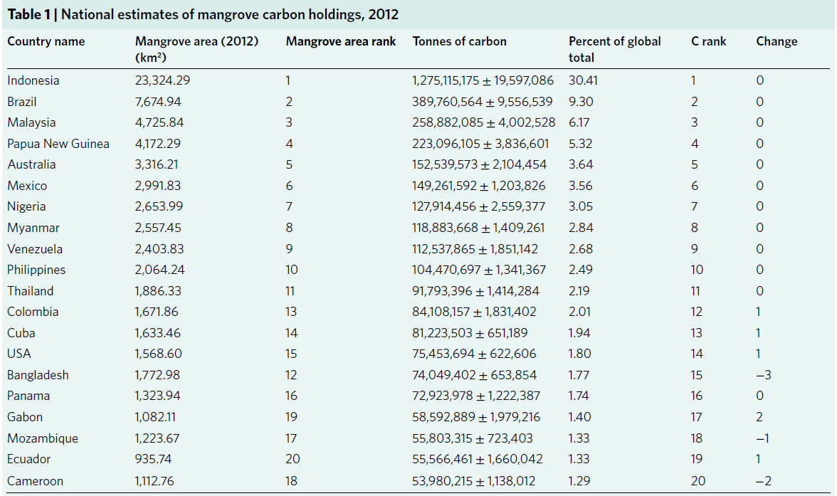
In the last decades mangroves have undergone a strong decline due to deforestation, land conversion and coastal development, the global mangrove loss rates is estimated to be equal to 0.16-0.39 % annually, 8.08 % in south east asia (Hamilton and Casey, 2016). According to Pendleton et al. (2012) 0.15–1.02 Pg of carbon dioxide are being released annually from mangrove deforestation and over the 1996-2016 period there has been an estimated decline by 158 Mt C of global mangrove carbon stocks (Richards et al., 2020).
The preservation and restoration of wetlands has been shown to be an effective climate change mitigation strategy (Taillardat et al., 2020). The carbon budget is best constrained for mangroves, with mangroves globally taking up 700 Tg C yr⁻¹ through Gross Primary Production, and respiring 525 Tg C yr⁻¹ (75%) back to the atmosphere as CO2 (Alongi, 2014 in Macready et al., 2019). In the framework of blue carbon projects mangrove restoration has the highest climate change mitigation potential per area of implementation (figure 1., Lovelock & Reef, 2020).
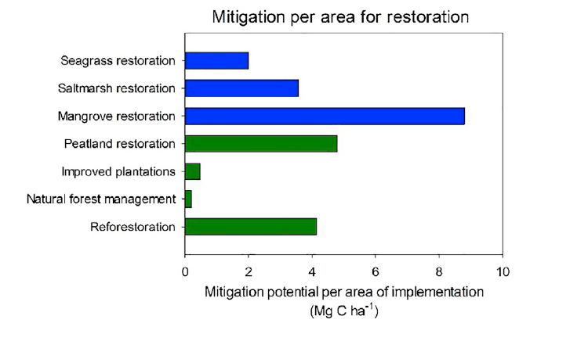
Figure 1. Mitigation potential of nature-based solutions for climate change in blue carbon, adopted from Lovelock & Reef, 2020.
Furthermore, mangroves have a rapid recovery rate, plantation on abandoned aquaculture ponds can show similar net primary productivity and carbon sequestration to natural mangrove forest, as was shown in a case study in Bali, Indonesia (Sidik et al., 2019).
There is considerable variability in carbon store in mangroves based on carbon turnover rates via leaf or litterfall production rate (Saenger & Snedaker, 1993) that can be visualized by differences in canopy cover (Simard et al., 2019). Other variables also impact the biomass of mangrove, for example cyclone disturbance, that seems to have an influence on canopy height at regional scale (Farfan et al., 2014). Mangrove biomass can be significantly variable depending on the spatial location and on the environmental variables they are exposed to (Mitra et al., 2011).
A very important component of the carbon stock of mangrove ecosystem is represented by the soil level that can represent from 49 to 98% of the carbon stock (Donato et al., 2011). However, there is also a high spatial variability in carbon storage in the soil with a mean organic carbon soil content to 1 m depth of 361 ± 136 Mg C ha⁻¹ and a range of 86 to 729 Mg C ha⁻¹ (Sanderman et al., 2018). Both geographical conditions and forest characteristics (e.g. species composition) play an important role in the variability observed among different mangrove forest even in the same area. Bangladesh has the lowest per ha stocks average (127 Mg C ha⁻¹), this is most likely due to high allochthonous input of mineral sediments in the Sudarbans fluvial system (Banerjee et al., 2012).
It is important to distinguish between carbon stock and carbon sequestration. Carbon stock is defined as the carbon stored in the forest at a certain time, whereas with carbon sequestration the increase of carbon in a system over a period of time is indicated (Takimoto et al., 2008). Estimates of carbon sequestration can be calculated by considering the primary production of the system and the emissions via respiration (Alongi, 2014), alternatively if the forest age is known an estimate of the carbon accumulation over time can be calculated from the carbon stock of the ecosystem. Most studies reported in literature measure carbon stock of the forest, mostly with indirect methods (i.e. by using estimates from biomass values with allometric equations and carbon conversion factors), while there is limited availability of direct estimates of carbon sequestration.
The estimation of net primary productivity (NEP) shows variability among different locations and forest type, and is also dependent on the calculation method utilized in the study and the more or less accurate inclusion of all ecosystem components and input\ output of carbon (Poungparn & Komiyama, 2013). For example values of NEP can go from 7.75 Mg C ha⁻¹ y⁻¹ in a Xylocarpus and Bruguiera forest in Eastern Thailand (Poungparn et al., 2012) to 21.42 Mg C ha⁻¹ y⁻¹ in a mature mangrove forest in Australia (Alongi, 2011).
Looking at the carbon stock, biomass carbon shows a quite high variability depending on the species composition of the forest, Liu et al. (2014) analyzed the carbon stock in different mangrove forest in China and they reported a range of C from 19.45 ± 9.05 Mg C ha⁻¹ for a Sonneratia caseolaris monospecific stand to 217.18 ± 126.35 Mg C ha⁻¹ for a stand of the introduced mangrove species Sonneratia apetala. This species was introduced from Bangladesh to China and is characterized by rapid growth and biomass carbon accumulation, but also high invasiveness. Yu et al. (2020) reported that S. apetala at 15 years can reach a similar biomass to a 40 year old natural forest in China, although having lower soil ecosystem carbon density. An overview of the results of the above mentioned study is reported in Table 2.
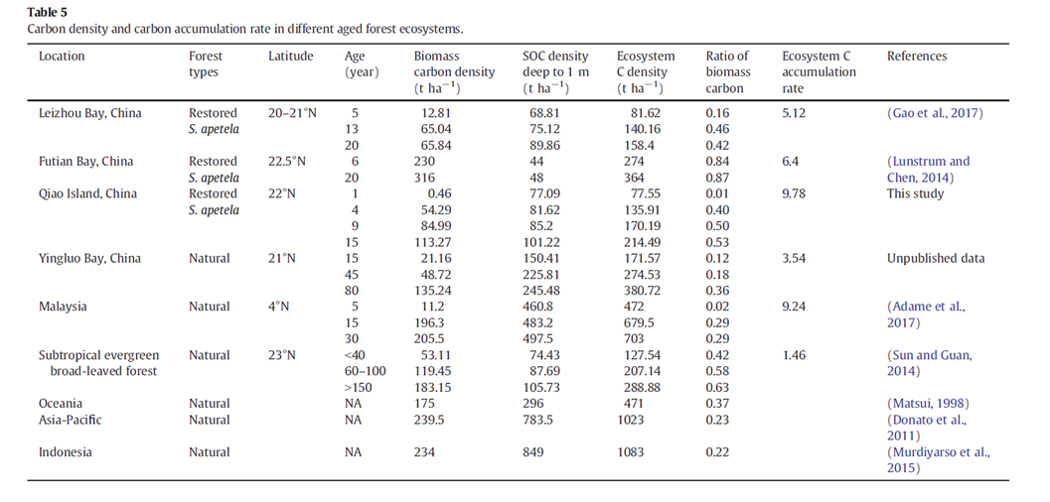
Table 2. carbon density in S. apetala planted forests in China compared to natural forest in China and other countries, adopted from Yu et al. (2020).

The carbon soil stock depends, among other factors, on the forest density and the geography of the forest. In a study by Cadiz et al., 2020 in Trang, Thailand carbon stock in sediments was compared between a 25 years old planted forest and a >50 years old natural forest and found higher carbon in the planted forest (272.49 ± 19.16 Mg C ha-1 vs 254.73 ± 11.74 Mg C ha-1), probably due to higher tree density in the former one and different species composition (a mainly Rhizophora planted forest compared to a mixed species forest).
Variability in carbon ecosystem estimations is also given by the uncertainties in root biomass estimation, as root biomass estimations obtained with allometric equations provide values 40 ± 12 % larger than field measurements (Adame et al., 2017)
The Matang Mangrove Forest Reserve (MMFR) in Malaysia is a well-known example of mangrove plantation. Its management is going on since 1902 (Arifin & Mustafa, 2013) specifically for the production of poles and charcoal from Rhizophora apiculata Blume and Rhizophora mucronata Lamk. with a rotation plan of thirty years (with two thinnings at 15 and 20 years and clearfelling at 30 years). The biomass carbon stock of the MMFR was recently estimated by Barrios-Trullols (2017) based on biomass values from Goessens et al. (2014) (Table 3), while the carbon storage in the soil was measured for some forest stands by Adame et al. (2018), which leads to estimates of carbon ecosystem stocks of 385.2 ± 72.6 Mg C ha⁻¹ at a clearcut site and 895.8 ± 113.9 Mg C ha⁻¹ for a protective 70 year old stand.
Table 3. Biomass carbon storage in Matang mangrove forest reserve and calculation of annual carbon storage (Barrios Trullols, 2017), Annual carbon storage was calculated according to the following equation: Annual Carbon storage = Total C stock / tree age (De Villiers et al., 2013)
Forest age (years) | Total carbon storage (MgC ha⁻¹) | Annual carbon storage (MgC ha⁻¹ y⁻¹) | Annual carbon storage (MgCO₂ ha⁻¹ y⁻¹)
15 | 113.19 | 7.55 | 27.68
20 | 115.63 | 5.78 | 21.19
30 | 197.85 | 6.59 | 24.16

References
Adame, M. F., Cherian, S., Reef, R., & Stewart-Koster, B. (2017). Mangrove root biomass and the uncertainty of belowground carbon estimations. Forest ecology and management, 403, 52-60.
Adame, M. F., Zakaria, R. M., Fry, B., Chong, V. C., Then, Y. H. A., Brown, C. J., & Lee, S. Y. (2018) Loss and recovery of carbon and nitrogen after mangrove clearing. Ocean & Coastal Management, 161, 117-126.

Ahmed, N., & Glaser, M. (2016) Coastal aquaculture, mangrove deforestation and blue carbon emissions: Is REDD+ a solution? Marine Policy, 66, 58-66.

Alongi, D. M. (2011). Carbon payments for mangrove conservation: ecosystem constraints and uncertainties of sequestration potential. Environmental science & policy, 14(4), 462-470.

Alongi, D. M. (2014) Carbon cycling and storage in mangrove forests. Annual review of marine science, 6, 195-219.

Arifin R. & Mustafa N.M.S.N. (2013) A Working Plan for the Matang Mangrove Forest Reserve, Perak (6th revision). Malaysia: State Forestry Department.

Aziz, A. A., Thomas, S., Dargusch, P., & Phinn, S. (2016) Assessing the potential of REDD+ in a production mangrove forest in Malaysia using stakeholder analysis and ecosystem services mapping. Marine Policy, 74, 6-17.

Banerjee K, Chowdhury M R, Sengupta K, Sett S and Mitra A 2012 Influence of anthropogenic and natural factors on the mangrove soil of Indian Sundarbans wetland Arch. Environ. Sci. 6 80–91.
Barrios Trullols, A., (2017) Can mangrove silviculture in Matang Mangrove Forest Reserve, Malaysia be carbon-neutral ?, MSc Thesis Univeristé Libre de Bruxelles, Belgium.

Bouillon, S., Borges, A. V., Castañeda‐Moya, E., Diele, K., Dittmar, T., Duke, N. C., ... & Rivera‐Monroy, V. H. (2008). Mangrove production and carbon sinks: a revision of global budget estimates. Global biogeochemical cycles, 22(2).

Bunting, P., Rosenqvist, A., Lucas, R. M., Rebelo, L. M., Hilarides, L., Thomas, N., ... & Finlayson, C. M. (2018). The global mangrove watch—a new 2010 global baseline of mangrove extent. Remote Sensing, 10(10), 1669.

Donato, D. K. J. B., Kauffman, J. B., Murdiyarso, D., Kurnianto, S., Stidham, M., & Kanninen, M. (2011) Mangroves among the most carbon-rich forests in the tropics. Nature geoscience, 4(5).
Hamilton, S. E., & Casey, D. (2016). Creation of a high spatio‐temporal resolution global database of continuous mangrove forest cover for the 21st century (CGMFC‐21). Global Ecology and Biogeography, 25(6), 729-738.Pendleton et al., 2012
Farfán, L. M., D’Sa, E. J., Liu, K.-b & Rivera-Monroy, V. H. Tropical cyclone impacts on coastal regions: the case of the Yucatán and the Baja California Peninsulas, Mexico. Estuar. Coasts 37, 1388–1402 (2014).
Goessens, A., Satyanarayana, B., Van der Stocken, T., Zuniga, M. Q., Mohd-Lokman, H., Sulong, I., & Dahdouh-Guebas, F. (2014) Is Matang Mangrove Forest in Malaysia sustainably rejuvenating after more than a century of conservation and harvesting management? PloS one, 9(8), e105069.

Hamilton, S. E., & Friess, D. A. (2018). Global carbon stocks and potential emissions due to mangrove deforestation from 2000 to 2012. Nature Climate Change, 8(3), 240-244.
Liu, H., Ren, H., Hui, D., Wang, W., Liao, B., & Cao, Q. (2014). Carbon stocks and potential carbon storage in the mangrove forests of China. Journal of Environmental Management, 133, 86-93.
Lovelock, C. E., & Reef, R. (2020). Variable Impacts of Climate Change on Blue Carbon. One Earth, 3(2), 195-211.

Macreadie, P. I., Anton, A., Raven, J. A., Beaumont, N., Connolly, R. M., Friess, D. A., ... & Lovelock, C. E. (2019). The future of Blue Carbon science. Nature communications, 10(1), 1-13.

Pearson, T. R., Brown, S., & Casarim, F. M. (2014) Carbon emissions from tropical forest degradation caused by logging. Environmental Research Letters, 9(3), 034017.

Poungparn, S., & Komiyama, A. (2013). Net ecosystem productivity studies in mangrove forests. Reviews in Agricultural Science, 1, 61-64.
Poungparn, S., Komiyama, A., Sangteian, T., Maknual, C., Patanaponpaiboon, P., & Suchewaboripont, V. (2012). High primary productivity under submerged soil raises the net ecosystem productivity of a secondary mangrove forest in eastern Thailand. Journal of tropical ecology, 28(3), 303-306.

Richards, D. R., Thompson, B. S., & Wijedasa, L. (2020). Quantifying net loss of global mangrove carbon stocks from 20 years of land cover change, Nature Communications https://doi.org/10.1038/s41467-020-18118-z

Robiou Du Pont, Y., Jeffery, M. L., Guetschow, J., Rogelj, J., Christoff, P., & Meinshausen, M. (2017) Equitable mitigation to achieve the Paris Agreement goals. Nature Climate Change, 7, 38- 43.

Saenger, P. & Snedaker, S. C. Pantropical trends in mangrove above-ground biomass and annual litterfall. Oecologia 96, 293–299 (1993).
Sanderman, J., Hengl, T., Fiske, G., Solvik, K., Adame, M. F., Benson, L., ... & Duncan, C. (2018). A global map of mangrove forest soil carbon at 30 m spatial resolution. Environmental Research Letters, 13(5), 055002.
Sidik, F., Fernanda Adame, M., & Lovelock, C. E. (2019). Carbon sequestration and fluxes of restored mangroves in abandoned aquaculture ponds. Journal of the Indian Ocean Region, 15(2), 177-192.

Simard, M., Fatoyinbo, L., Smetanka, C., Rivera-Monroy, V. H., Castañeda-Moya, E., Thomas, N., & Van der Stocken, T. (2019). Mangrove canopy height globally related to precipitation, temperature and cyclone frequency. Nature Geoscience, 12(1), 40-45.

Sivakumar, M. V., & Stefanski, R. (2010) Climate change in South Asia. In Climate change and food security in South Asia (pp. 13-30). Springer, Dordrecht.

Stocker, T. F., Qin, D., Plattner, G. K., Tignor, M., Allen, S. K., Boschung, J., ... & Midgley, B. M. (2013) IPCC, 2013: climate change 2013: the physical science basis. Contribution of working group I to the fifth assessment report of the intergovernmental panel on climate change.

Taillardat, P., Thompson, B. S., Garneau, M., Trottier, K., & Friess, D. A. (2020). Climate change mitigation potential of wetlands and the cost-effectiveness of their restoration. Interface Focus, 10(5), 20190129.
Takimoto, A., Nair, P. R., & Nair, V. D. (2008). Carbon stock and sequestration potential of traditional and improved agroforestry systems in the West African Sahel. Agriculture, Ecosystems & Environment, 125(1-4), 159-166.

Twilley, R. R., Chen, R. H., & Hargis, T. (1992) Carbon sinks in mangroves and their implications to carbon budget of tropical coastal ecosystems. Water, Air, & Soil Pollution, 64(1), 265-288.

Villiers, C. D., Chen, S., Jin, C., & Zhu, Y. (2013). Carbon Sequestered In The Trees On A University Campus. In Seventh Asia Pacific Interdisciplinary Research in Accounting Conference, Kobe.

Yu, C., Feng, J., Liu, K., Wang, G., Zhu, Y., Chen, H., & Guan, D. (2020). Changes of ecosystem carbon stock following the plantation of exotic mangrove Sonneratia apetala in Qi'ao Island, China. Science of The Total Environment, 717, 137142.

